**Find Assignment**

**1.Search and display all *.c and *.h files in all subdirectories starting from current directory**

find . -type f \( -name "*.c" -o -name "*.h" \)

**2. Search and display all directories in all subdirectories starting from current directory**

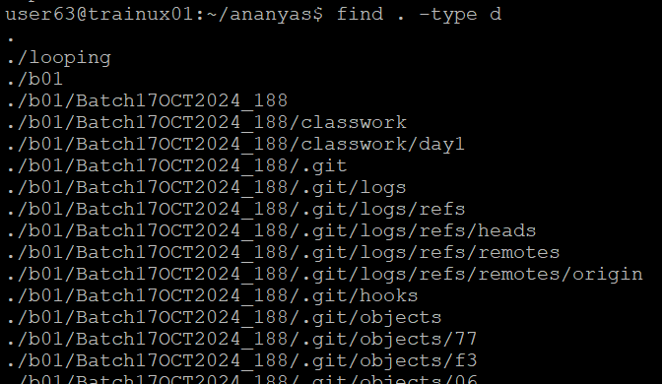find . -type d

**3. Search and display all files with permissions only rw with user and execute permission for others**

